

Date: **<To>**

TO WHOM IT MAY CONCERN

It is certified that Mr. **<Name>** S/O **<Fname>** CNIC No. **<CNIC>** in our organization as **<Designation>** in South Punjab Hospital from **<From> to <To>.**

During Service we found him hard working and professionally sound. We wish him great success in his future.

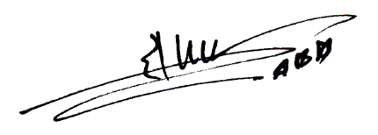Managing Officer

**South Punjab Hospital Suraj Miani Road Chungi No.1**